Intentions for the Week
If Mass time is underneath, Mass will be celebrated in the Church

Please remember the Obligation to attend Sunday Mass is suspended at present.

Sat/Sun | 2nd Sunday of Advent
4th  Dec  5th  Dec | St. Mary’s Vigil  St Bede’s Vigil  St. Bede’s  St. Matthew’s  St. Joseph’s | 5.30pm  6.00pm  9.30am  10.00am  11.00am | People of the Parish  People of the Parish – extra Mass  People of the Parish  People of the Parish available on You Tube  People of the Parish
Mon | Weekday of Advent
6th  Dec | St. Mary’s  St Bede’s | 10.00am  10.00am | Veronica Blakey  Domenico Esposito
Tue | St Ambrose Bp
7th  Dec | St. Matthew’s  St Bede’s | 10.00am | Requiem: Elsie Hammond  No Mass
Wed | The Immaculate Conception of the Blessed Virgin Mary
8th  Dec | St. Matthew’s  St. Joseph’s | 10.00am  10.00am | Fr. Michael Corbett  Repose of the Soul of Barbara & Michael Grey
Thur | Weekday of Advent
9th  Dec | St. Mary’s  St Bede’s | 11.30am  7.00pm | Requiem: Margaret Cullen  Confirmation Mass
Fri | Weekday of Advent
10th  Dec | St. Mary’s | 10.00am | Allan Lowdon
Sat | Weekday of Advent
11th  Dec | St. Bede’s  St. Matthew’s | 10.00am  10.00am | People of the Parish  Tom O’Malley (10th Anniversary)
Sun | 3rd Sunday of Advent
11th  12th  Dec | St Mary’s Vigil  St Bede’s Vigil  St. Bede’s  St. Matthew’s  St. Joseph’s | 5.30pm  6.00pm  9.30am  10.00am  11.00am | People of the Parish  Suor Concetta & Family Esposito  People of the Parish  People of the Parish available on YouTube  People of the Parish

Remember those who have asked for our prayers: Father Kevin Daly St. Bede’s: Maria Birrell, Ellen Trotter, A sick person SJ, Maureen Collins, Matthew Pimm, Catherine McQuilliam, Lily and Eddie McGloughlin; St. Joseph’s: Kathleen Maher, Lesley Brewis, S.P, Sharna Dixon Scott, K.D, Brian Race, Alice Williams, Irene Thompson & Wendy English. St. Mary’s: Lawrence Rowan, Stella Brunton, Agnes McGinley, Josie White, Joan & Bill McStea, Ewen Murry & Fr Bernard Allon. St. Matthew’s: Amelia, BCP, Liz Jeynes, Amariye, O.H., Brian, Anne, Kath Pitman, Joseph V Nicol, Royston, baby Taylor and Mam, Les Conroy and Chris Ford .

Second Sunday of Advent  5th December  2021  Latest News | The Catholic Parishes of Jarrow  Diocese of Hexham & Newcastle a Registered Charity No. 1143450  Saint Bede’s Saint Mary’s  Chapel Road, Jarrow, NE32 3LX Glasgow Road, Jarrow, NE32 4AU  stbedesrcchjarrow@yahoo.co.uk stmarysrcchjarrow@yahoo.co.uk  Fr Adrian Dixon 489 7364 Fr Saji Thottathll 489 7907  Saint Joseph’s Saint Matthew’s  Saint Joseph’s Way, Jarrow, NE32 4PJ York Avenue, Jarrow, NE32 5LP  saintjosephjarrow@yahoo.co.uk stmatthewsrcchjarrow@yahoo.co.uk  Fr Adrian Dixon 489 7364 Fr Saji Thottathill 489 7295  Website: jarrowcatholic.org.uk Facebook: St Josephs & St Bede’s Churches Jarrow  Deacon for Jarrow: Rev Kevin Atkinson Tel 0191 483 2679 Mobile 0771 173 6599  Parish Sister at St Bede’s: Sr Mary Lees  Hospital Chaplains: Newcastle Hospitals 2336161; RVI + Freeman  Fr Arockia Mariadass 2655290, or part time Rev Richard McLaughlin 2336161  Gateshead QE, Dunston Hill, Bensham: Rev Peter Jones QE 4820000, ext 2072;  Sunderland Royal: Mrs Linda Longstaff 5656256, or 5699180
d
Sunday of the Year
Reme
32
nd
Sunday of the Year
Reme

For Christmas Mass Bookings please ring the numbers below.
Only ring the number taking bookings for your own parish.
No texts, message or e-mails, please. You will be asked to give contact details.
Please note the phones will not be answered outside of the hours.

St Bede’s and St Joseph’s 07716941690
Bookings commence Monday 6th December until Tuesday 21st December
Booking Times: Mon 10am-12pm Tues 10am-12pm and Friday 6pm-8pm

St Matthew’s / St Mary’s 07513143133
Bookings commence from Tuesday 7th December until Wed 22nd December
Booking times: Tues 11.30-13.30pm, 6-8pm, Wed 11.30-13.30pm , Fri 11.30-13.30pm
Christmas Mass Times – booking required for Christmas Eve and Day
Christmas Eve 4.30pm St. Mary’s First Mass of Christmas
5.00pm St. Joseph’s First Mass of Christmas
6.30pm St. Matthew’s First Mass of Christmas
7.00pm St. Bede’s First Mass of Christmas

Christmas Day 9.00am St. Mary’s Mass of Christmas Day
10.00am St. Bede’s Mass of Christmas Day
10.00am St. Matthew’s Mass of Christmas Day

Feast of the Holy Family No Booking Required
Boxing Day 9.00am St. Mary’s Mass of the Feast Day
9.30am St. Bede’s Mass of the Feast Day
10.00am St. Matthew’s Mass of the Feast Day
11.00am St. Joseph’s Mass of the Feast Day

Advent Penitential Service There will be one service for the Jarrow Parishes on Monday 20 December at Saint Matthew’s 6.00pm.
Covid Restrictions: Our current practice is to use Hand Sanitisers and Face Coverings. Social distancing of 1 metre and the one-way system continues. Booking for Mass is not necessary; however the Government ask that we continue to keep a record of those at Mass for track and trace.

First Confessions Please pray for the children from our Primary Schools who will be making their First Confessions this week;

Christmas Candles We shall have candles at Saint Bede’s for those we remember to remain lit from Christmas Eve until Christmas Day. If you would like a candle to bear the name of a loved one please write the name on an envelope with payment inside (suggested donation £5). The envelope should be handed in to Saint Bede’s no later than Sunday 19 December.
The Northern Cross has struggled to keep afloat during recent months. It is on sale in church this weekend price £1.50. Please support our Diocesan Newspaper as it struggles to recover from the effects of the pandemic.

St Matthew’s: As always as Christmas approaches please consider donating to charity instead of a Christmas gift. or as a partial gift to your favourite charity whatever it may be. CAFOD World Gifts is one means of giving ethically at Christmas and helping those most in need to build a better future. A few leaflets are at the church exit or visit cafod.org.uk, tel 08081400014 mon-fri to order.

Vacancy - "Free Help with Debt" project, led by The Parish of Jarrow and Simonside in partnership with South Tyneside Churches Together, Key2Life Foodbank, Communities Together Durham and the Diocese of Durham. Do You Want to Make a Difference? Could you be our CMA Connect Free Help with Debt Centre Manager? Free Help with Debt is a new project based in Jarrow, which will reach out to people struggling with money and/or mental health issues. This is an opportunity to oversee and coordinate the development of a new volunteer initiative delivering locally based accessible support. Closing date for applications: Monday 6th December 2021. For details and an application form contact irenemac2010@gmail.com

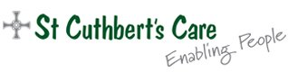
Advent Alms 2021. This Advent, we ask you to consider supporting St Cuthbert’s Care; we provide frontline registered care services for people with complex disabilities, residential homes and fostering for young people and two Catholic nursing homes for older people. Advent donations will help buy gifts for all our residents in our care this Christmas, along with new electronic devices to help our older residents keep pace with our digitised world. Your support is precious to us and helps us to continue to provide outstanding care and peace of mind to families. Thank you so much. Moira Ashman CEO, St Cuthbert’s Care. 0191 228 0111; Email: enquiries@stcuthbertscare.org.uk

200 Club November 1st Maria McBride 35, 2nd L Potts 104, 3rd G Shearer 195

St Matthew’s Missio Red Boxes: Contributions for the Missions are now due to be collected. We will aim to distribute as many calendars as possible over the coming weeks. If possible please hand your red box to a steward at the back of church. Please make sure your name is on it . If necessary we are happy to collect. Tel 4212816

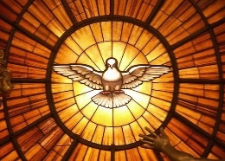
Confirmation There will be a rehearsal this Sunday 5 December at 5.30pm for the Confirmation Mass which takes place on Thursday 9 December at 7.00pm in Saint Bede’s. You are welcome to come along to the Mass to support our young people as they reach this important moment in their spiritual lives.

Refugee and Asylum Seekers Project Food donations, St Matthew’s and St Mary’s. Many thanks for your support which provides invaluable help to those destitute and struggling to survive. Please continue to leave donations of tinned foods, toilet roll, biscuits, sugar, rice (not microwaveable), in sealed bags in the designated container at the entrance to your church. Your donations will be taken to the project at St Vincent’s Centre, Blackfriars on a monthly basis.

Please pray for Fr Peter Smith, Terry Convery and Thomas Robinson who died recently. May they rest in Peace.

A special welcome to Libby Francesca and Lottie Rose Preston who were recently Baptised at St. Mary’s.
The Sanctuary Lamp will burn in St. Bede’s for the memory of Jack & Mazel Welsh & Doreen Conner, in St. Joseph’s for Robert, Mary & Winifred Croft, St Matthew’s in memory of Kit Hobbs RIP

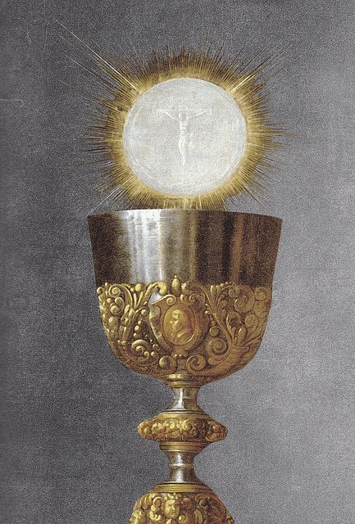
St Matthew’s: During the Year of the Eucharist, there will be Exposition from 9am, with the Rosary at 9:30am before all weekday services, but NOT Sunday Mass; On Wednesday evenings from 7 - 8pm Exposition with silent prayer. St Matthews Rosary Prayer Group meets each Thursday, 7 - 8pm, including Exposition. Exposition with silent prayer Sundays, 4 - 5pm, apart from the first Sunday of each month. Further events based on the theme of the Eucharist will be announced in due course.
St. Joseph’s: Advent: Time Before the Lord Tuesday evenings
6 - 7:30 pm starting 23rd November and ending 14th December.

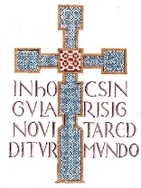
For those whose anniversaries occur about this time: St. Joseph’s Robert Henry Oswald Croft, Terence Stuart, John Maloney & Syd Linskill.

St Matthew’s Mass Intentions. We have an ongoing backlog of intentions which will take some time to work through. Your patience is very much appreciated.

MarriageCare Relationship Counsellor Our existing Diocesan Counsellors have been stretched more than ever. If you are interested in this fulfilling work please do not hesitate to contact Marriage Care for details www.marriagecare.org.uk/crc

Sunday Mass will be live streamed from St Matthew’s on YouTube.

“Christmas revels the Immense love of God for humanity. From that flows also the enthusiasm, the hope of us Christians, that in our poverty we know that we are loved, we are visited, accompanied by God.
(Pope Francis)

