**SERVICE TIMES & MASS INTENTIONS SATURDAY 6.00pm Vigil** Michael Baird(St Aloysius) **SUNDAY**  **9.15am** People of the Parish(St James) **11.00am**  Agnes & Patrick Campbell, Peggy & Andy Vickers(St Aloysius) **MONDAY St Bonaventure 9.30am** Private Intention(St Aloysius) **TUESDAY Our Lady of Mount Carmel**  **9.15am** Christopher & Teresa Kirwan(St James) **WEDNESDAY**  **7.00pm** Mary & Ralph Williams(St James) **THURSDAY**  **11.30am** Funeral Service for Terry Joyce(St Aloysius) **7.00pm** Audrey Mullen(St Aloysius) **FRIDAY**  **9.30am** People of the Parish(St Aloysius)  **SATURDAY**  **6.00pm Vigil** Kathy Gordon(Sick)(St Aloysius) **SUNDAY 16th Sunday of the Year B 9.15am**  Agnes Swan(St James) **11.00am** Owen Paton(St Aloysius)

**Prayers for the sick especially:** Little Charles, Michael Abbott, Teresa Brady, Darren Brown, Dorothy Burton, Andy Griffin, Eleanore Mae Gurthrie, Liam Hackett, Sick Person, Dave Hallway, Pat Henderson, Mark Hepburn, James Mole, Mary Moore, Catherine Pilkington, Pat Richardson, Sick Person MF, Gerard Leake, Rita Knowles, Sick Person SH, Sick Person CT, Sick Person MAJ, John McKie, Everleigh Rose, Sick Person FB, Sick Person AP, Charlotte Nelist, Doreen Lynch.

**Those who have died recently:** Terry Joyce, Michael Addison.

**Anniversaries**: Jean Lynch, Bernadette Douglass, Gerard Milne, Kathleen Hanwell, James Turner, Jack French

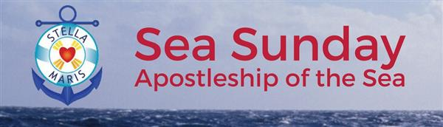

**St Aloysius and St James Hebburn**

Parish Priest Fr Simon Weymes 0191 4832165 Parish Deacon Rev Peter Jones 0191 4834781 Email Address [staloysiusandstjames@gmail.com](mailto:staloysiusandstjames@gmail.com)

**14th July 2024**

**Fifteenth Sunday of the Year B**

**Mass Book p.106**

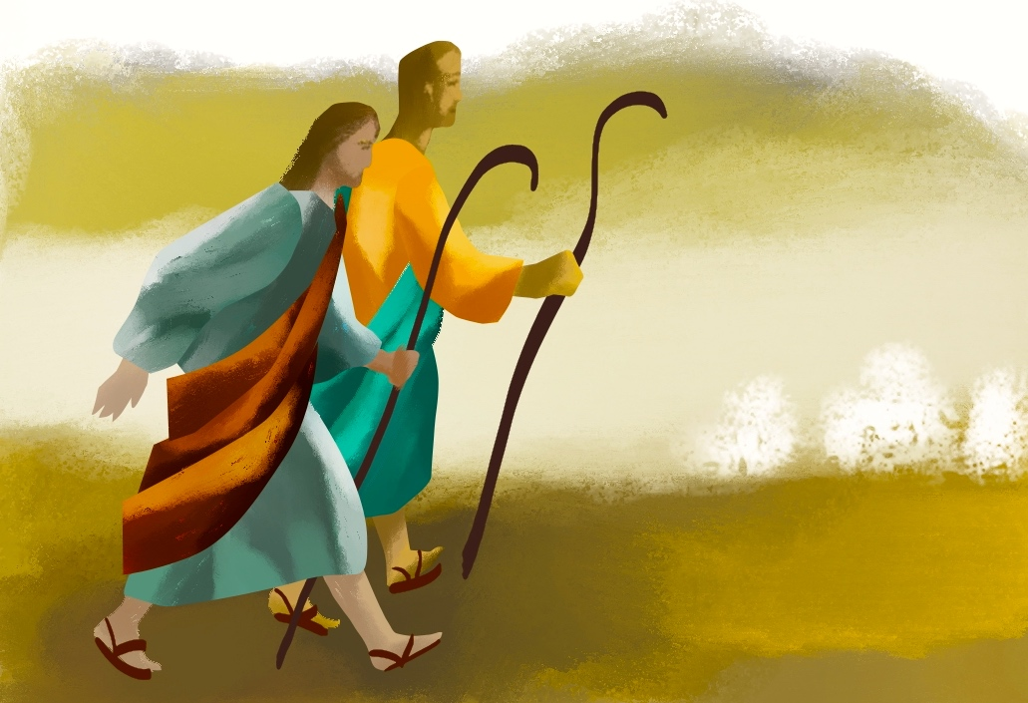

**Jesus sent them out ahead of him in pairs**

**USEFUL INFORMATION** Parish Website staloysiusstjames.com St Aloysius School 0191 4832274 St James School 0191 4832672 St Joseph’s School 0191 4282700 Jarrow Website jarrowcatholic.org.uk South Shields Website cpsswb.weebly.com Diocesan Listening Service 07384853672

**SVP**

Our SVP is willing to help anyone, individual or family, who needs some help and support at this time. If you know anyone who is in need, and could do with a little help, please let us know. Please note it’s important that the person/persons concerned should give their consent. Tel. 07894416679

**WELCOME**

We welcome those who have been baptised recently, Addis Kelly, Lucas, Oliver and Theadore Ray, Rosa Matilde Dos Santos Turton, Frankie Ronald Johnson, Taylor Steven Maxwell, Poppy Ruth Leake, Hollie Gibson, Frankie Wright, Oliver Matthew Reeves and Nina Quinn Mayhew-Watt.

**THANK YOU**

The family of David Scullion would like to thank everyone for their kindness, cards and support. We were overwhelmed by the number of people who attended both the mass and committal. A fantastic £1160 was collected for Brain Tumour Research. Thank you.

**PRAYER MEETING**

Prayer Meeting at St James on Tuesdays at 7pm. All are welcome.

**SUMMER FAIR**

Thanks for all the hard work in preparing for the Fair, and all those who supported it. We raised £1,938.78 for much needed parish funds.

**FUNERALS**

Requiem Mass for Michael Addison St Aloysius Mon 22nd July 9.15am

**SCHOOLS END OF YEAR MASSES**

Wednesday 17th July 9.45am St James School. 1.30pm St Aloysius Church

**STELLA MARIS**

The annual appeal for the Apostleship of the Sea will take place this weekend there will be a retiring collection at the end of each mass.

**NEW LECTIONARY**

The Bishops of England, Wales and Scotland have decided that we need a new translation of the Scripture we use in our Masses. This new translation is based on both the English Standard Version-Catholic Edition of the Bible and the Abbey Psalter for the psalms. This means that we will need to buy four new volumes of the Lectionary for each church. Your own Sunday Missal will need to be replaced too, new ones can be ordered, they cost £20 or £30 for a leather-bound missal. The change happens at the beginning of Advent.

**DIOCESAN NEWS**

**PROUD CATHOLICS** LGBT+ Catholics meet 3rd Tue of month 7.30pm St Andrew’s Worswick St. in Newcastle. More info. Tel: 07858934457

**MARY, STAR OF THE SEA, LIGHT OF EVERY OCEAN**  
guide seafarers across all dark and stormy seas  
that they may reach the haven of peace and light  
prepared in Him who calmed the sea.  
As we set forth upon the oceans of the world  
and cross the deserts of our time, show us, O Mary,  
the fruit of your womb, for without your Son we are lost.

Pray that we will never fail on life’s journey,  
that in heart and mind, work and deed,  
in days of turmoil and in days of calm,  
we will always look to Christ and say,  
“Who is this that even wind and sea obey him?”  
Our Lady of Peace, pray for us!  
Bright Star of the Sea, guide us!