At first sight this is a surprising gospel reading for Pentecost, but of course the event of Pentecost came too late to be a subject for the gospels, and we read the account of another incident where the Risen Christ gave the Spirit to his disciples. There are two emphases in the account. The first is peace. Christ brings peace to his disciples with the double greeting of peace, and peace is a Christian watchword. Peace was the song of the angels at Jesus’ birth. Each of Paul’s letters opens with a greeting of peace. The letter to the Ephesians proclaims that Christ is our peace, the removal of all worry, strife, envy, jealousy, self-seeking ambition. ‘Go in peace’ is Jesus’ dismissal of those he cures, and also the dismissal at the end of Mass. Peace was Jesus’ bequest to his disciples after the Last Supper.
The second watchword is forgiveness, for God was always known as a God of mercy and forgiveness, as Jesus came to show by his constant approach to sinners. But the Lord’s Prayer shows that if we do not ourselves forgive, we block God’s forgiveness of ourselves too.
‘Forgiveness is the only sure path to peace.’ Does this cause any difficulties?
Which is more important to you, peace or forgiveness? Or are they the same?

Vigils | Holy Rosary  Sacred Heart | 5.30 pm  6.30 pm | A sick person  People of the Parish
Sun  6th  Aug | THE TRANSFIGURATION OF THE LORD
Sun  6th  Aug | St Bede’s  St Gregory’s  Ss Peter & Paul  St Oswald’s  St Bede’s | 9.30 am  9.30 am  10.30 am  11.00 am  5.00 pm | Stuart Miller  People of the Parish  Special Intention  Bob Spinks  People of the Parish & Partnership
Mon  7th Aug | Weekday
Mon  7th Aug | St Oswald’s  Holy Rosary | 9.00 am  10.00 am | Les Pallas  Margaret Pearson +
Tues  8th Aug | St Dominic
Tues  8th Aug | Holy Rosary  St Oswald’s  Ss Peter & Paul  St Gregory’s | 9.15 am  10.00 am  10.00 am  6.30 pm | Private Intention  Bob Spinks  Priest’s Intention  Anne Seymour (MC)
Wed  9th Aug | St Teresa Benedicta of the Cross, Patron of Europe
Wed  9th Aug | Sacred Heart  Ss Peter & Paul  St Bede’s | 10.00 am  10.00 am  12.00 pm | Priest’s Intention  Priest’s Intention  Maria Rodrigues & Sebastiao Rebello
Thurs  10th Aug | St Laurence, Deacon & Martyr  St Bede’s 10.00 am A. Young –( Sick)
Thurs  10th Aug | St Vincent’s  Ss Peter & Paul | 10.00 am  7.00 pm | Helen Kelly  Priest’s Intention
Fri  11th Aug | St Clare of Assisi
Fri  11th Aug | St Oswald’s  St Gregory’s  Holy Rosary | 9.30 am  10.00 am  12.00 pm | Knut & Enid Try  Harry & Dec’d Mem of Suthern Family  40 year Charismatic Renewal
Sat  12th Aug | Weekday
Sat  12th Aug | St Bede’s  St Gregory’s | 10.00 am  10.00 am | Anne Clarke  Austin McClean
Vigils | Holy Rosary  Sacred Heart | 5.30 pm  6.30 pm | Beatrice Louise Wilson  Priest’s Intention
Sun  13th Aug | 19th SUNDAY OF THE YEAR
Sun  13th Aug | St Bede’s  St Gregory’s  Ss Peter & Paul  St Oswald’s  St Bede’s | 9.30 am  9.30 am  10.30 am  11.00 am  5.00 pm | Jack & Florrie Kelly  People of the Parish  Sick & Housebound SVP  People of the Parish  People of the Parish & Partnership
THE TRANSFIGURATION OF THE LORD 6th AUGUST 2017

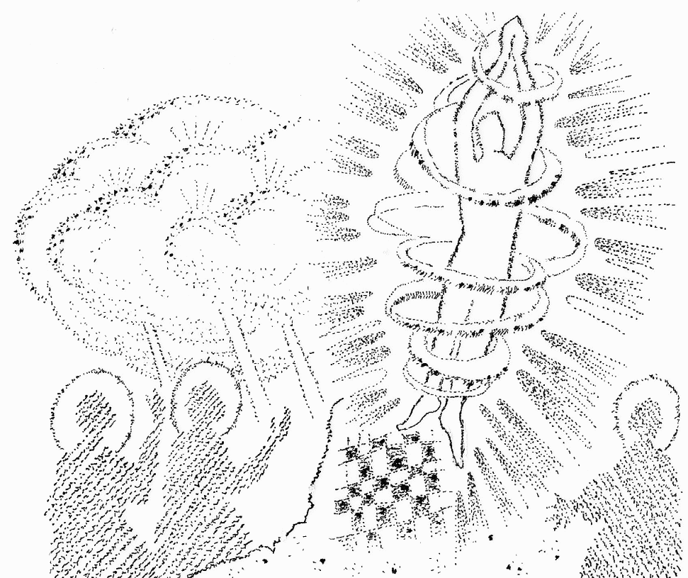
STEP 1: RELAX & REMEMBER: Remember that through this scripture our Lord is truly present. Read the Gospel, pay attention to any words that stand out & meditate on them for a few minutes and be invited into a dialogue with God.
STEP 2: READ THE GOSPEL: The Transfiguration (Matthew 17:1-9)
STEP 3: REFLECTION
Mark’s was the first Gospel to be written; he gives the basic account which Matthew and Luke both use. This commentary looks first at Mark, then at the changes made by Matthew and Luke. Mark’s Gospel has been described as ‘a Passion Narrative with extended introduction.’ In this second half of the Gospel, everything is overshadowed by the Passion of Jesus. The disciples are going to be stunned and shaken by the Passion, when their loved and awesome leader is taken from them and tortured to a humiliating death. So beforehand God allows them to see the other side, to see Jesus for what he really is. They see his features as a heavenly person, transformed with the divine light and clothed in dazzling garments. With him are the two heavenly figures who had experience of God on the Holy Mountain, Moses and Elijah, for this is an experience of Jesus as God. The overshadowing cloud is further evidence of the divine presence. The Voice that spoke to Jesus at his baptism now speaks to them all, authenticating Jesus as God’s Son and chosen teacher. The disciples are literally ‘gob stopped’, and want to preserve the experience by building three shelters for the heavenly visions. But such an experience, like any mystical experience of the divine, is not to last. They must return to the business of living their daily lives in the light of this overwhelming experience. Matthew’s account is almost the same as Mark’s. He adds the detail of Jesus’ face shining like the sun. This was the case with Moses when he encountered God on the Holy Mountain, and Matthew, writing for Jewish Christians, is always keen to stress that Jesus was a Second Moses. He also changes the reaction of the disciples: in Mark, they are so scared that they do not know what to say, but in Matthew, they fall to the ground and do reverence, and Jesus gently raises them up. Luke stresses that Jesus went up the mountain to pray. He frequently stresses Jesus’ constant need for prayer, and many of Luke’s parables are about prayer (the Importunate Widow and the Unjust Judge, the Pharisee and the Tax Collector). Luke also details that Jesus, Moses and Elijah were conversing about his journey up to Jerusalem, a journey that is the theme of the latter half of Luke’s gospel. Jesus went up the Holy Mountain to pray. Where do you like to pray? What do you find the best form of prayer?
STEP 4: RESPOND & REQUEST:
Now slowly and prayerfully read the Gospel once again but this time in silence. Consider how this Gospel could apply to your life in general. Then thank God for any insight you may have received. Conclude by asking God to bless you with one of the following spiritual gifts to help you act on any resolution you have made: love, understanding, wisdom, faithfulness, peace, self-control, patience or joy. Please remember to pray for the Church and particularly our school families. Then conclude by requesting the prayers of Our Lady & St Joseph.

.

Adoration of the Blessed Sacrament: St Bede’s Saturday 9.00 - 10.00 am
Sacrament Of Reconciliation St Bede’s Saturday 10.30 - 11.00 am
(Confessions) Holy Rosary Saturday 5.00 - 5.30 pm
Sick: Please pray for Hazel Prowse, Michael Dawson, Derek Aynsley, Carol Dawson, Michelle Greatrex, Mary Clarke, Robert Scott, Gloria Dearden, Terry Wales, Vivienne Scott, Tony Manson, Marian Sykes, Monica Kippax, Eric Walker, Poppy Cox, Christopher Phillips, Ruth Lynch, Bridie Weymes, Vincent Carrahar and Sharon Hutchinson.
RIP: Please pray for Mary Theresa Smith who died recently and for all whose anniversaries occur at this time.
“Those who die in grace go no further from us than GOD and He is very near.”
St Bonaventure.
Baptism:, Arabella Rai will be baptised today Sun 6th Aug at St Bede’s, welcome to the Parish.
Fund raising for Kelly: If you missed last weekend there will be another opportunity to donate by contributing to a special collection at St Bede’s & Holy Rosary this weekend.
Children’s Liturgy: Will resume again in September, when the new school year begins.
Funeral: A Service for Mary Therese Smith will take place at South Shields Crematorium on Tue 8th August at 11.15 am. May she rest in peace.
Dorcus Prayer Group: meet every Wed 2.00pm ‘Praise & Worship’ 172 Bamburgh Ave. All welcome.
Thanks: to all who came along to the Coffee Day in aid of Breast Cancer Care. Total raised £485. Thank you for your support. Catherine & Margaret.
Congratulations: To Jenny & Jim Frazer who celebrated their 75th Wedding Anniversary last Tuesday. They were married at Ss Peter & Paul on 1st August 1942
HOLY ROSARY FINAL MASS: the last Vigil Mass at Holy Rosary will be Sat 9th Sept at 5.30 pm. The Closing Mass of the church will be celebrated by Bishop Seamus on Wed 13th Sept 7.00 pm. A meeting will be arranged soon to confirm where we will assemble for our Vigil Mass in the future and look at the pastoral care of Horsley Hill & Marsden.
Fashion Show: in St Bede’s Parish Hall Thurs. 7th Sept 7.00 pm. Tickets £5. (including refreshments) obtainable from Catherine or pay at the door. All proceeds to St Clare’s Hospice. Would anyone be willing to serve Tea/Coffee during the interval? Tel. Catherine 07733174475 or 4566207.

What are we prepared to give up for the Gospel? Do we try to make our own cross, or accept whatever we are given? To give up all your possessions is to make yourself vulnerable and dependant. This gospel teaching could cause all kinds of problems between families, friends and colleagues.
St Paul, in putting himself in the place of the slave, Onesimus, is encouraging the church leader, Philemon, to do what is right. But his words are equally for us today. We have the example of many such as Maximilian Kolbe who took the place of a man condemned to death in a concentration camp. We are called to lose our comfort zones, our assumed places and see each human being through the `lens’ of the gospel message of freedom and dignity. We follow Jesus, that through his Paschal Mystery, He may lead us out of the world of selfishness and violence we have made, into a new heaven and new earth, where all is shaped by the generous and merciful ways of his Father.

Confessions: Saturday 6.00–6.30 pm.
Please pray for:Prof.Paul Younger, Fr John Gibbons, Leo Hardy, Ronnie Phelps, Kurt Patterson, Carol Hannen, Hazel Watson, Jessie Gray, Patricia McKeag, Janet Hymers, baby Evie Noble, and all the sick in St Benedict’s, St Clare’s Hospices and all those in South Tyneside Hospital. If there is anyone ill or housebound and not being visited, please inform John Hardy.
ROTAS |  | 5th August
Readers: |  | K Smith V Green N Johnson
Ministers: |  | J Hardy D Godfrey
B.Prayers: |  | M Tierney
Counters: | Mr and Mrs Tierney | Mr and Mrs Smith
Food Aid: A box is at the back of church for donations of food or money. Maureen Hunter continues to collect stamps for Cystic Fibrosis. If you are able to knit simple hats, scarves or mittens for the Christmas Shoebox Appeal please speak to Maureen for more details. Anniversaries: William Young, William Brown, Oswaldo Leonardo Riani, Alice Rice, Robert Bernard Dowell, Nora Maria Ablett, Robert Foster, Winifred Ford, Terence Gorman, Catherine Veronica Kimmett, Thomas Hemingway, David Bruce, Winifred Dine, Lilian Cordina, Joan Mary Younger, Richard Stanley Melville (Moore), John Hall, Nora Westgarth.
Do you have any news for our bulletin? If you would like something included during August please contact Myris on 07956 068 156 by Tuesday evening.

ST OSWALD’S

Anniversaries: Charlotte Pino, Sheila Byrne, Elizabeth Diamond & Joan Younger.

Please pray for: Leo Hardy, Doreen Carrahar, Rosemary Cox, Eva Todd, Cathy Spinks, John Elrick, Richard Cook, Peter Hanratty and all the sick and housebound.

This week (6 Aug): Eucharistic Ministers: M. Frazer, P. Brown, T. Fitzpatrick.
Reader: A. Hutton. Bidding Prayers: M. Tierney.

Next week (13 Aug): Eucharistic Ministers: P. Gulbrandsen, G. Kendall, J. Hutton.
Reader: M. Ellenden. Bidding Prayers: M. Hunter.

Notices & Intentions: Catherine Slater 5369248 / Teresa Featherstone 5374285.
100 Club: Winning number for week 29 – No.68 L. Pallas.

Welcome: Hello again to Fr. John, who is saying Sunday Mass for us while our Fr. John enjoys his holiday.
Eucharistic Ministers: When you are taking your turn as a Eucharistic Minister, can you please make arrangements between you to wash the chalices and ciboriums after Sunday Mass. Thank you.

Cycle of Prayer Up till September we are asked to pray for these intentions: A Deeper Understanding between Christians and Jews; Those Who Suffer Persecution, Oppression and Denial of Human Rights; Europe; Human Life; Seafarers.
The Pope’s Mission Intention August: that through their creativity, artists of our time may help everyone discover the beauty of creation. “The way to seek God is through prayer that is transparent and unafraid to hand over to him our troubles, our struggles and our resistance.” Pope Francis
Holyday: Tue 15th August is the Feast of the Assumption, a Holyday of Obligation. Mass times will be published soon.
De La Salle: 1. De la Salle Focus 50p group is open on a Monday evening in St Gregory’s hall 6 –7-30 pm to any young person yr 7+ It’s a session of fun with games and crafts.
2. Youth Mass Wednesday 23rd August 7.00 pm St Gregory’s. All are welcome to come along and support the youth.
Thanks: to all who came along to the Coffee Day in aid of Breast Cancer Care. Total raised £485. Thank you for your support. Catherine & Margaret.
Day Outing to the Scottish Borders Dumfries Wednesday 30th August coach departs St Gregory’s at 8.45 am Landreth House at 9.00 am fare £10 per head to book a seat please Tel. Frankie 0191 4562466 Mobile 07506553178 many thanks for your continued support.
Called to the Supper of the Lamb: Day of Reflection for Eucharistic Ministers led by Fr Shaun Purdy, Ushaw College Sat 9th Sept. 10.30 am-4.00 pm. Booking is essential. Please add your name to the list at the back of church before 21 August.
HOLY ROSARY FINAL MASS: the last Vigil Mass at Holy Rosary will be Sat 9th Sept at 5.30 pm. The Closing Mass of the church will be celebrated by Bishop Seamus on Wed 13th Sept 7.00 pm. A meeting will be arranged soon to confirm where we will assemble for our Vigil Mass in the future and look at the pastoral care of Horsley Hill & Marsden.
Fashion Show: in St Bede’s Parish Hall Thurs. 7th Sept 7.00 pm. Tickets £5. (including refreshments) obtainable from Catherine or pay at the door. All proceeds to St Clare’s Hospice. Would anyone be willing to serve Tea/Coffee during the interval? Tel. Catherine 07733174475 or 4566207.
Ministeracres Weekend Retreat: October 6th, 7th, 8th 2017. Price £120, deposit £25 to Angela Hudson, 5363305. Transport arranged.

Tue 8th Aug: 6:00pm: Exposition of the Blessed Sacrament
Wed 9th Aug: 10.00 – 10.15 am Private Prayer & Reflection
Fri 11th Aug: 9.30 am: Morning Prayers of the Church.
Sat 12th Aug: 9:30am: Rosary for Vocations

The Sick: Ellie Kraal, Gordon DeLooze, Terry Hagan, Joan Stewart, Gloria Dearden, Betty Devine, Joan Robson, Rona Bojke, Rose Scott, David Frame, Anthony Balfour, Norman Scott, Benedict O’Donohoe, Len Gardner, Clifford and Christopher Browne, Derek Aynsley, Robert Tracey.

Anniversaries: Sheila Spinks. Maureen Middlemas, Maureen Garett, Agnes Smith, Harry Suthern

Duty Rotas for 13th August:
9.30 am Mass at St Gregory’s: Welcomers: Susan Plunkett, Mary McGurk. Readers: Alan Cormack, Neil Jackson Jnr. Eucharistic Ministers: Nick Duffy*, Gillian Cormack, Des McGurk, Frances Harrison. Bidding Prayers: Jean Little. Coffee: Cathy Miller, Madeline Webster. Flowers: Christine Donkin. News Letter: Maureen Iveson.

Praise in the Park: Come and join Harton Churches Together at St Margaret’s on Sunday 13th August at 4:00pm.( Please bring your own sandwiches)

Ministeracres Weekend Retreat: October 6th, 7th, 8th 2017. Price £120, deposit £25 to Angela Hudson, 5363305. Transport arranged.

De La Salle Youth Mass: Wednesday 23rd August 7:00pm in St Gregory’s. All are welcome to come along and support the youth.

The Charlie Cookson Foundation: One of our parishioners, Michael Jordan, will be running the Great North Run. You can sponsor him after Mass during the coffee morning.

Wednesday Private Prayer: St Gregory’s Church will be open for prayer and private reflection from 10:00 am until 10:15 am, followed by coffee in the church hall.

R I P
Of your charity pray for the repose of the souls of….

6 Aug Blessed Pope Paul VI 1978
7 Aug Rev Edmund Kane 1960 Rev Sean Conaty 2011
8 Aug Rev James Saunders 1967
10 Aug Monsignor Gerard Lavender 2014
12 Aug Rev Donal Cronin 1999

“May they rejoice for ever in the vision of the mysteries
which they faithfully ministered here on earth.”
Roman Missal

Please pray for: Denis Wray, Alison Hannay, Bill Murtagh, Peggy Murtagh, Russell Little, Kathleen & Alan Potter, Anne Gray, Carrie Maxwell, Fr Michael Marr, Fr Bill Bellamy, Lorraine Steel, Margaret McLoughlin, Veronica Helps, Norma Richardson, Monica Gagliardi.

Sacrament of Reconciliation: Celebrated every Thursday from 6:30pm

Sanctuary Candle: If you are interested in dedicating a candle please see Fr Robert or John Tiernan.

Day Outing to the Scottish Borders Dumfries Wednesday 30th August coach departs St Gregory’s at 8-45am Landreth House at 9.00am fare £10 per head to book a seat please Tel. Frankie 0191 4562466 Mobile 07506553178 many thanks for your continued support.

SVP Fund Raising: the SVP are running a raffle for church funds. Tickets are £1 each and are available at the back of Church. Please support.

Piety Shop: A good selection of religious cards and gifts are available in the shop at the back of church and the Community Room, please support.

Tea and Coffee: served after Mass every Sunday

